

**Dr. BABASAHEB AMBEDKAR MARATHWADA UNIVERSITY, AURANGABAD**



**MGM’S**

**Dr. G. Y. Pathrikar College of Computer Science & Information Technology, Aurangabad -431003**

**(2019-2020)**

**Project Report**

**On**

**“Medical Billing Management System”**

**In partial fulfillment of requirement for the degree of Bachelor of Computer Science**

**Submitted By-**

**Suraj Chaudhary**

**Nikhil Borse**

**Kamaraj Babu**

**Komal Chavan**

**Guided By -**

**Dr. Yogesh Rajput sir**



**Dr. BABASAHEB AMBEDKAR MARATHWADA UNIVERSITY, AURANGABAD**



**MGM’S**

**Dr. G.Y. Pathrikar College of Computer Science & Information Technology, Aurangabad – (431003)**

**‘CERTIFICATE'**

This is to certify that, **Suraj Chaudhary**, **Nikhil Borse, Kamraj Babu, Komal Chavan** have successfully completed the project report on “Medical Billing System” for partial fulfillment of course B.Sc. (Computer Science) Sixth Semester, affiliated to Dr. Babasaheb Ambedkar Marathwada University, Aurangabad, during the Academic year( 2019-2020).

**Roll no: - (A0193008)**

**(A0193007)**

**(A0193014)**

**(A0193009)**

**Project Guide Head of Department**

**Dr. Yogesh Rajput Dr. S. Azade**

**Examiner**

**INDEX**

|  |  |  |
| --- | --- | --- |
| **Sr. no** | **Contents** | **Page no.** |
| **1.** | **Acknowledgement** | **4** |
| **2.** | **Introduction to project** | **5** |
| **3.** | **Introduction to PHP** | **7** |
| **4.** | **Introduction to MySQL and Sublime** | **8** |
| **5.** | **Scope and objectives** | **10** |
| **6.** | **Hardware and Software Requirements** | **11** |
| **7.** | **E-R Diagram** | **12** |
| **8.** | **Data flow Diagram** | **13** |
| **9.** | **User Interface Design** | **14** |
| **10.** | **Conclusion** | **31** |

**ACKNOWLEDGEMENT**

With the deep sense of gratitude, we would like to thank all the teacher who have shown path with their kind guidance. We are very grateful to these intellectuals who did best to help during our project works.

We remain indebted to our teachers for their timely suggestion and valuable guidance. The special gratitude towards Dr. Yogesh Rajput sir and staff members, of computer department for their expensive, excellent and precious guidance in completion of this work. And lastly, we thanks to our friends and the people who are directly or indirectly related to our project work.

**THANK YOU!**

**INTRODUCTION**

**Medical Shop**

This is an application project developed for **medical shops**. This system is a field concerned with selling medicines, maintaining their inventory, generating sales invoices about medicines. The aim is to automate its existing manual system by the help of computer software, so that their valuable/information can be stored for a longer period for is accessing and manipulation of the same.

Today the world’s most forward-looking medical agency are trying to provide more reliable and accurate services in their filed, offering services to the customers. Every shop now days is trying to computerize its activities to provide better services to its customers. This system enables to manage and record the activities of whole medical shop of multi-facility skills only. This system organizes their daily activities like billing, tablets information, stock details. In present these applications are use in every medical shop. These systems will save time and increase work efficiency.

Following are some important points covered by project members.

**Service: -**

Service is the entity offered by the medical shop and targeted to the customers. Each service is defined by us, which includes service type, name, billing policy. All of these attributes are described later in this article. After service ordering by the customer, it takes a unique ID which is attached with the medicine report of the customer, provided by the provisioning system to the customer at a certain date.

**Rating: -**

One of the big issues in any billing system is how, when, and where the shop Owner should bill their customers. Rating is the process of converting usage records from one form to another, like converting usage units to its cost. This process is essential in the billing process as it is the point of conversion of the service usage to revenue value to shop, which is the target of telecommunication companies.

**Invoices and payments: -**

Each customer in the billing process has an doctor prescription, which affects any invoices requested by the customer and any payments done by the customer. Normally the invoices are generated as a result of service hosting or using, and payments are the customer payments as a result of the invoicing operation.

**Invoice: -**

It is the entity generated by the billing system to inform the customer that he must pay for his service usage or ordering. Each invoice includes the customer doctor prescription date of payment, line items of the invoice, and invoice sales taxes. Invoices affect the account debits in the billing system. The invoice contents are shown in the following

**Payment: -**

It is the process of collecting shop money from the customers and adjusting their balances through adjusting the account debits and credits. The customers receive receipts of their payments. Each customer account should include its payment method to be used after generating invoices and to ask customers for payments.

**INTRODUCTION TO PHP**

PHP started out as a small open source project that evolved as more and more people found out how useful it was Rasmus Lerdorf unleashed the first version of PHP way back in 1994. PHP is a recursive acronym for “PHP: Hypertext pre-processor”. PHP is a server-side scripting language that is embedded in HTML. It is used to manage dynamic content, databases, session tracking, even build entire e-commerce sites.

IT is integrating with a number of popular databases, including MySQL, PostgreSQL, Oracle, Sybase, Informix, and Microsoft SQL Server. PHP performs system functions, i.e. from Fees on a system it can create, open, read, write, and close them. PHP can handle forms i.e. gather data from files, save data to a file, through email you can data, return data to user. You add, delete,modify elements within your database through PHP. Access cookie variables and set cookies. Using PHP, you can restrict users to access some pages of your website. It can encrypt data.

The PHP Hypertext Pre-processor (PHP) is a programming language that allows web developers to create dynamic content that interacts with databases’ is basically used for developing web-based software applications. This tutorial helps you to build base with PHP. PHP started out as a small open source project that evolved as more and more people found out his useful it was. Rasmus Leadoff unleashed the first version of PHP way back in 1994.

**Introduction to MySQL**

MySQL is an important component of an open source enterprise stack called XAMP. XAMP is a web development platform that uses windows at the operating system, apache as the web server, MySQL as the relational database management system and php as the object-oriented scripting language.

MYSQL is a freely available open source relational database management system (RDBMS) structured Query Language (SQL).

SQL is the most popular language for adding, accessing and managing content in a database. It is most noted for its quick processing, proven reliability, ease and flexibility of use. MySQL is an essential part of almost every open source PHP application.

We have long experience in providing technical support for MYSQL-based web site. Thanks to it our severs is perfectly optimized to offer the best overall performance for most MySQL application. We offer lot of free MySQL tools including CMS System, Forums, galleries, blogs, shopping carts and more. We support MySQL and we provide unlimited MySQL database on all our hosting plans.

**Introduction to Sublime (Text Editor)**

Sublime Text Editor is a full featured Text editor for editing local files or a code base. It includes various features for editing code base which helps developers to keep track of changes. Various features that are supported by Sublime are as follows −

* Syntax Highlight
* Auto Indentation
* File Type Recognition
* Sidebar with files of mentioned directory
* Plug-in and Packages

Sublime Text editor is used as an Integrated Development Editor (IDE) like Visual Studio code and NetBeans. The current version of Sublime Text editor is 3.0 and is compatible with various operating systems like Windows, Linux.

**The following is a list of features of Sublime Text:**

* "Go to Anything," quick navigation to files, symbols, or lines
* "Command palette" uses adaptive matching for quick keyboard invocation of arbitrary commands
* Simultaneous editing: simultaneously make the same interactive changes to multiple selected areas
* Extensive customizability via JSON settings files, including project-specific and platform-specific settings
* Compatible with many language grammars from Text Mate.

**Scope and Objective of Project**

Pharma Solutions is designed to focus on the medical store to help them in their billing management with taking care of other details like stock and accounting. As today in the country most of the medical stores are manual only which means they maintain their record of the person buying drugs and the quantity of it in the paper files, registers and binders.

This practice is very unreliable and prone to mistakes and omissions. The medical store billing system help the owner of the store in keeping the track of its customer and the drugs he/she is buying from store which further help it in the analysis of getting the stock for the next term. Usually when customer buy the medicines from the store the salesperson has to record his/her details in register then person also has to write the medicines details in separate record which is hectic and time consuming.

This system will automatically update the record in all database as customer buys the medicines which saves the store’s time and the resources. The following key points is considered for system-

**Objectives: -**

* for customer to buy the medicines
* A Payment details should be handled
* Store and maintain the detail information about medicines
* Easy updating and adding of stocks
* Record of customer to whom stock is sold.

The medical store billing system ease the medical shops and the salesperson by providing the fully computerized data storage facility which help them to generate the bill and update the record at the same time without any manual work.

**Hardware and Software Requirement**

**Hardware Information: -**

This project should work generally intends to act as a support for the all user. All the physical equipment, input devices, output devices and processor of the computer is ‘Hardware’.

**Hardware Specification: -**

* Printer (for ex. HP Desk Jet, Canon PIXMA etc.)
* A minimum of 4GB of RAM
* A minimum of 500GB of available space on the hard disk
* Sound card
* Keyboard and Microsoft Mouse or some other compatible pointing device
* Processor: - Minimum 2GHz**.**

**Software Information: -**

A set of instruction of programs to make the hardware platform for desired task is called ‘Software’. Software can also be defined as the utility programs that are required to drive the hardware of the computer.

**Following are the software necessities for the development of web application: -**

* Front End - **HTML, CSS,**
* Back End - **PHP, XAMP**
* System Requirements - (Windows 8, windows 10)
* Processor Speed - (Pentium 4, 2.00GHz or Power PC G5)

**E-R Diagram**

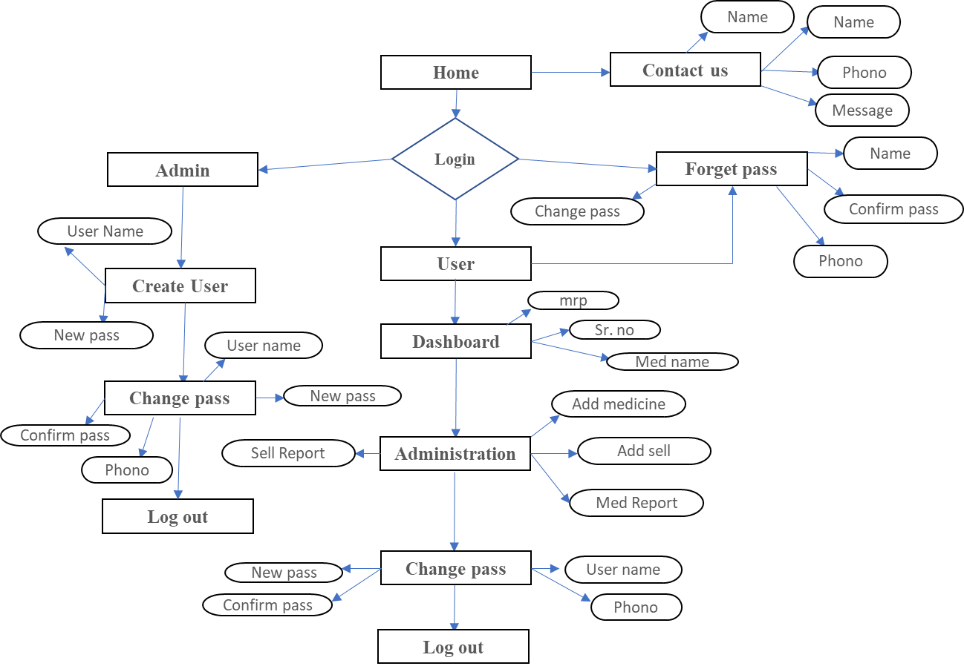

**DATA FLOW DIAGRAM (DFD)**

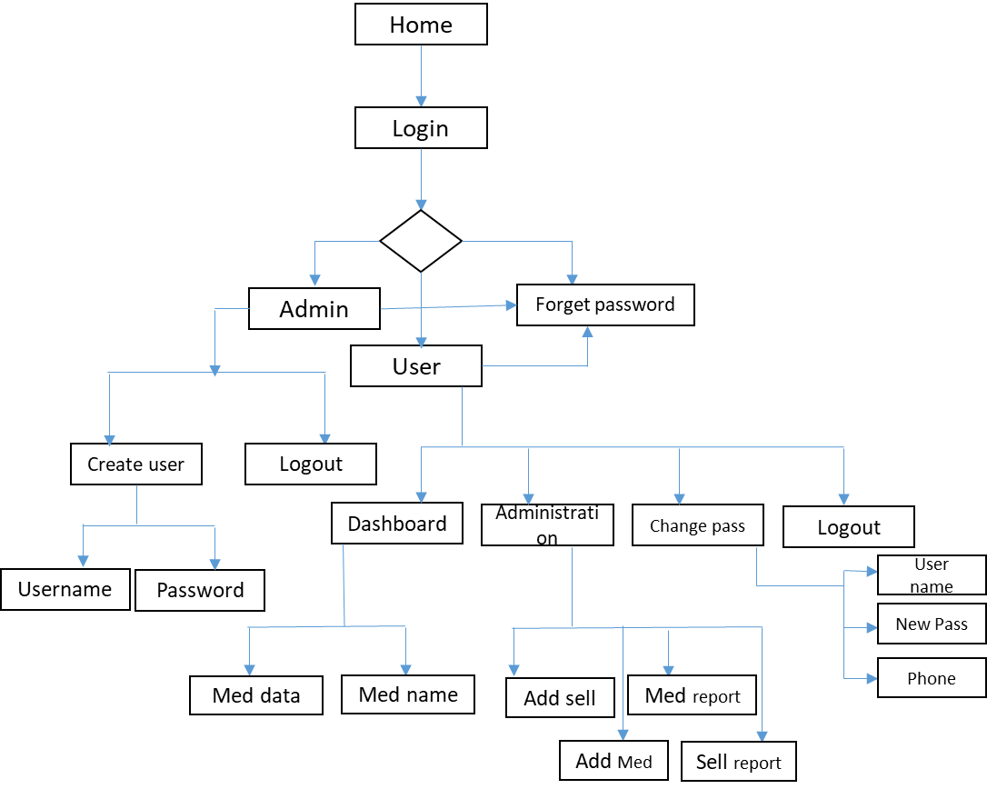

Diagram: -DFD (Data flow Diagram) Pharma solution

**USER INTERFACE DESIGN**

1. **Home Page**

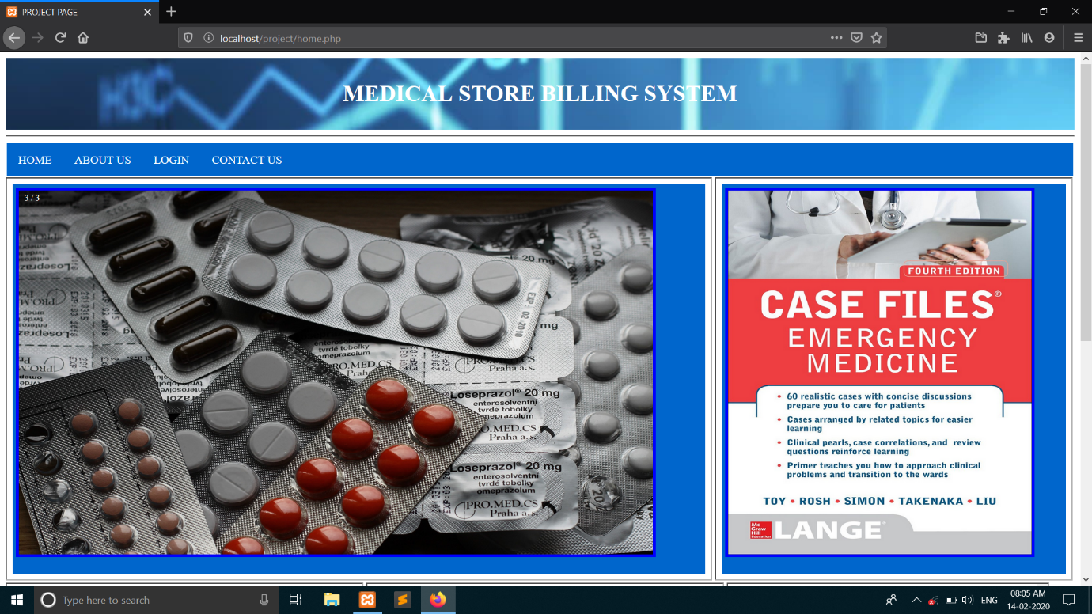

**2. Create new user (Admin)**

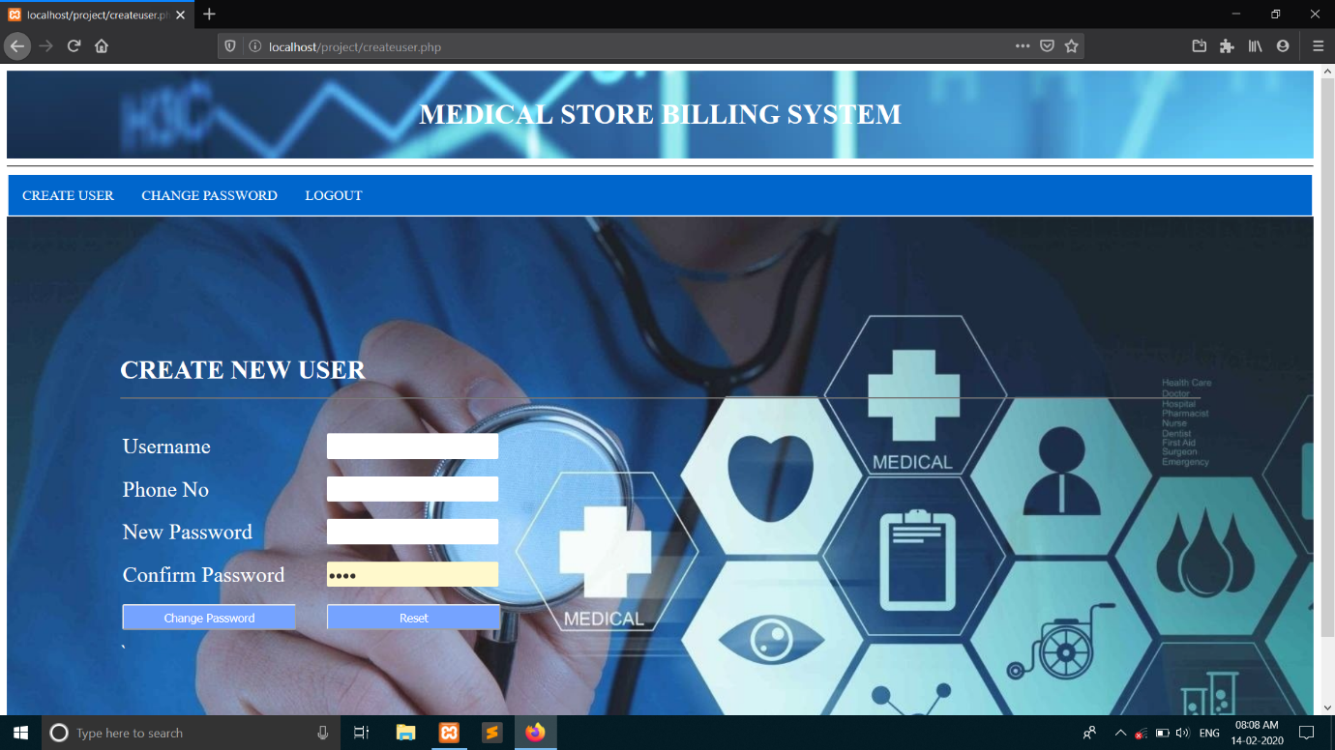

**3. Login Page**

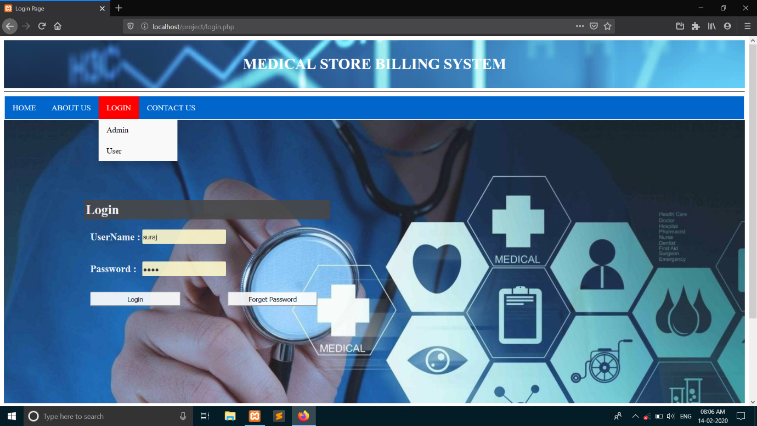

**4. Forget password.**

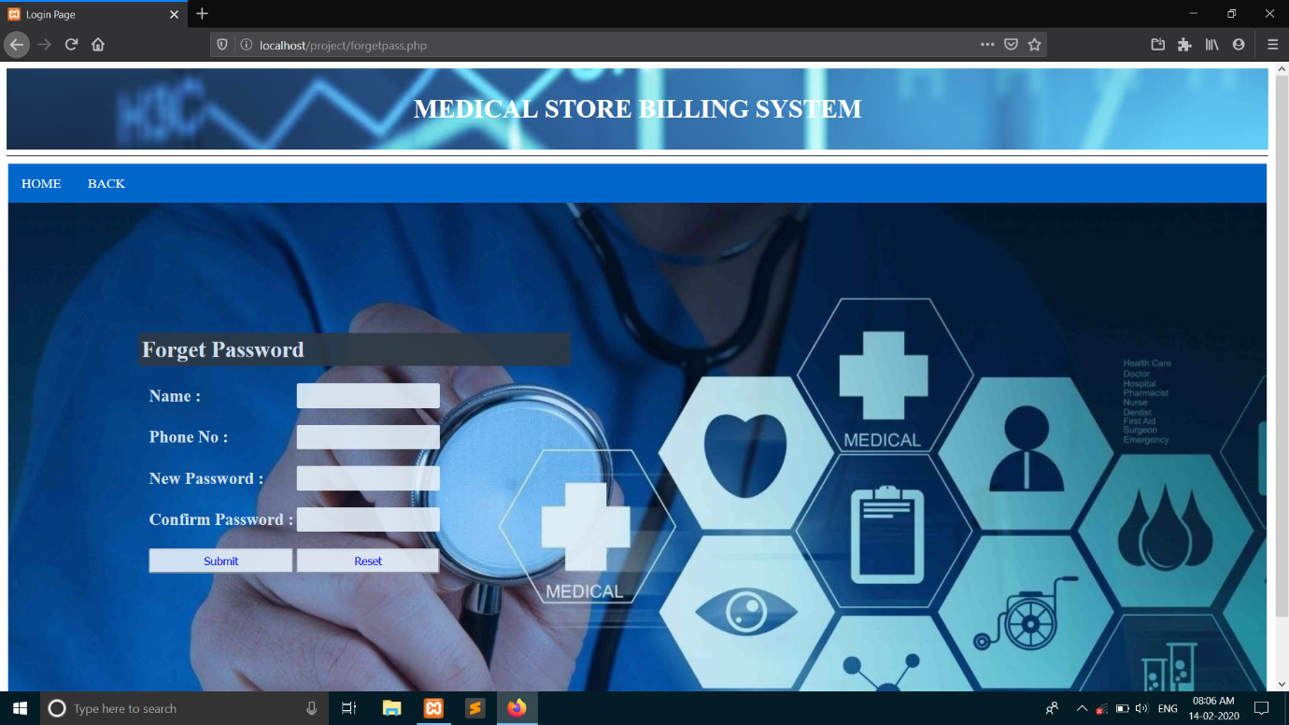

**5. Dashboard.**

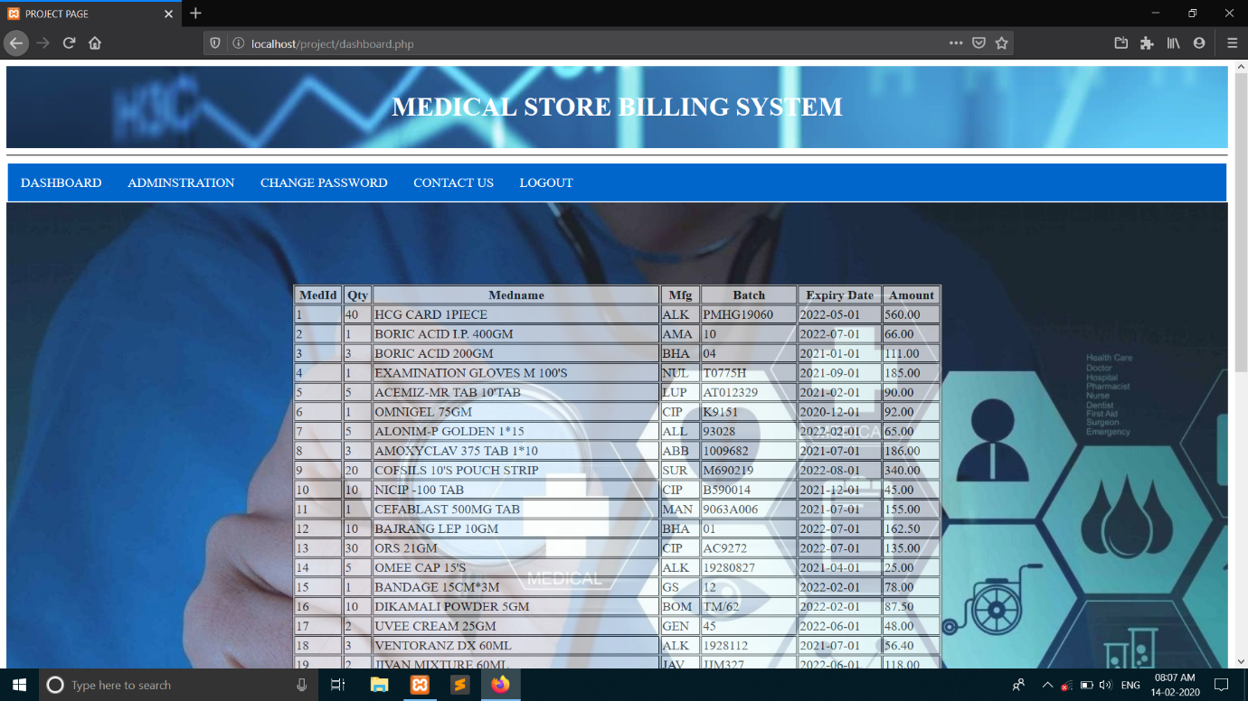

**6. Administration.**

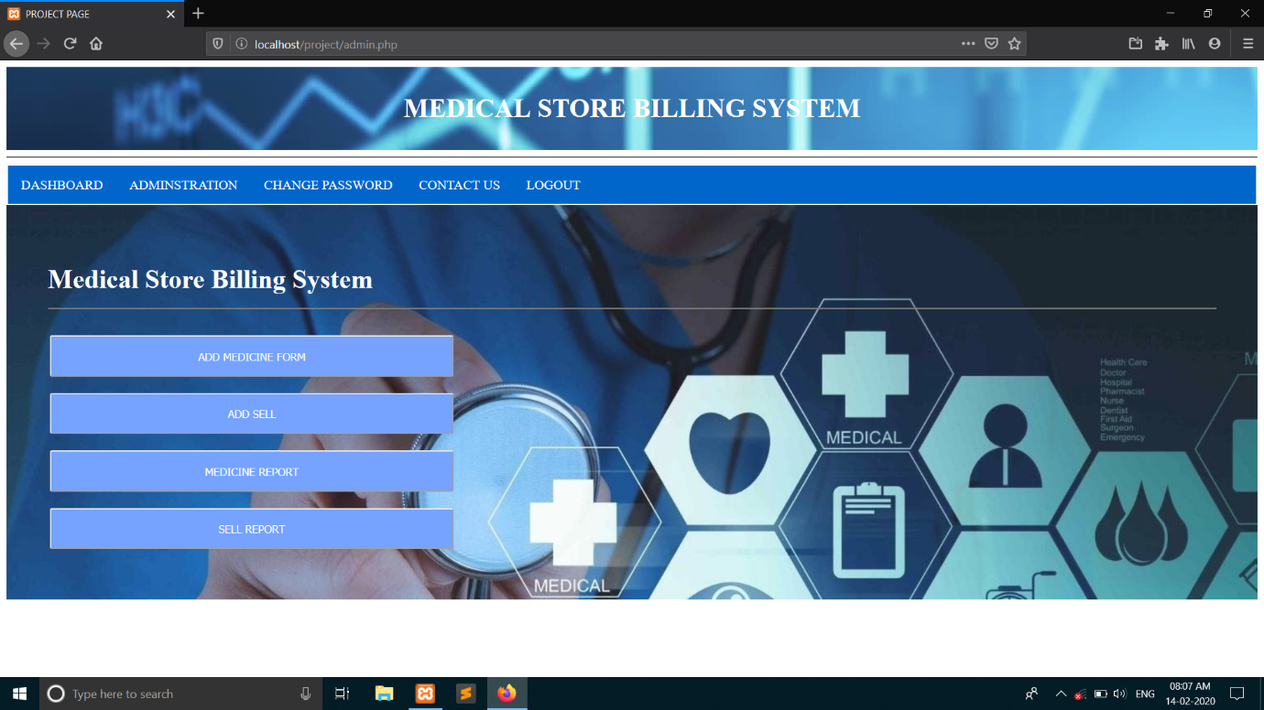

**7. Add Medicine form**

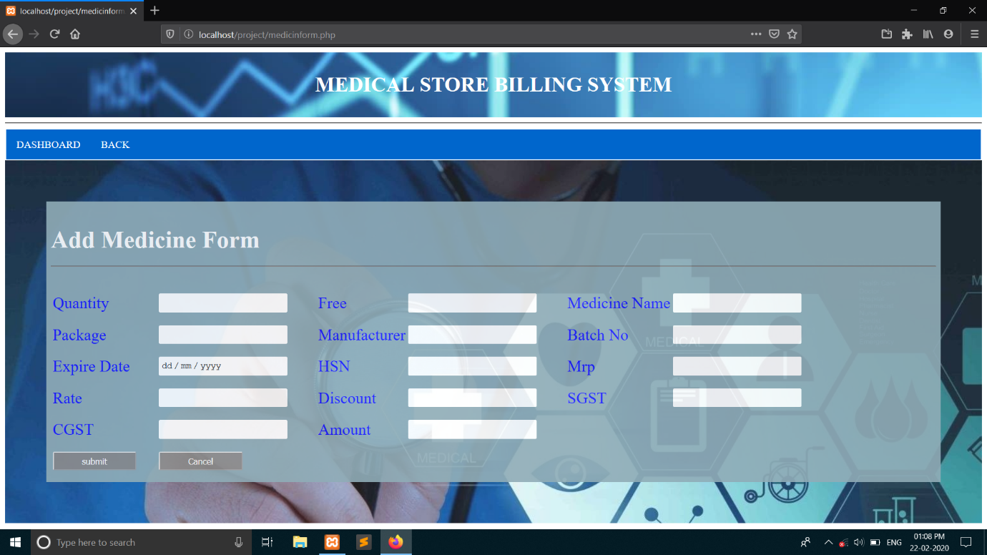

**8. Sell Report**

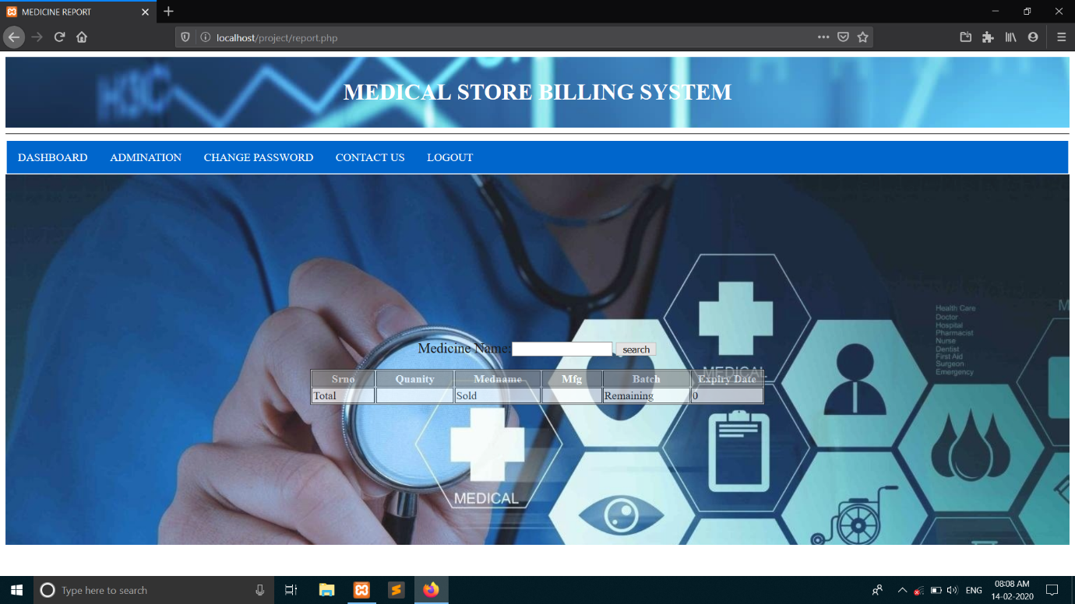

**9. Billing Page**

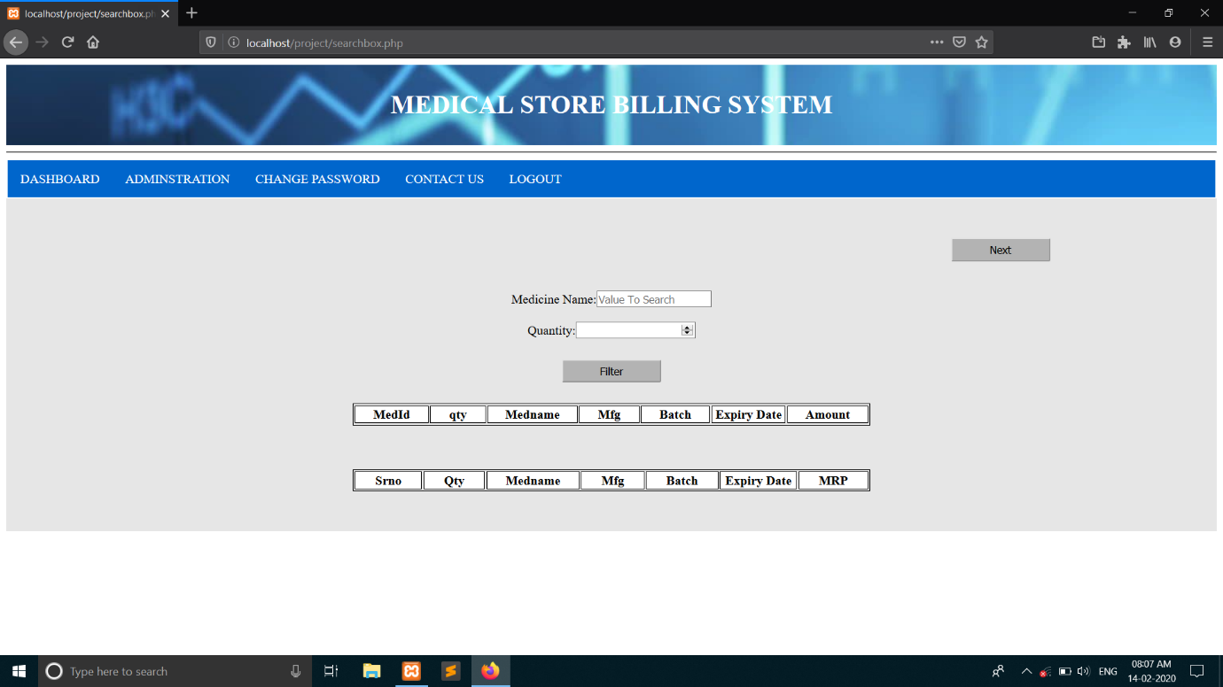

**10. Billing Page (Print).**

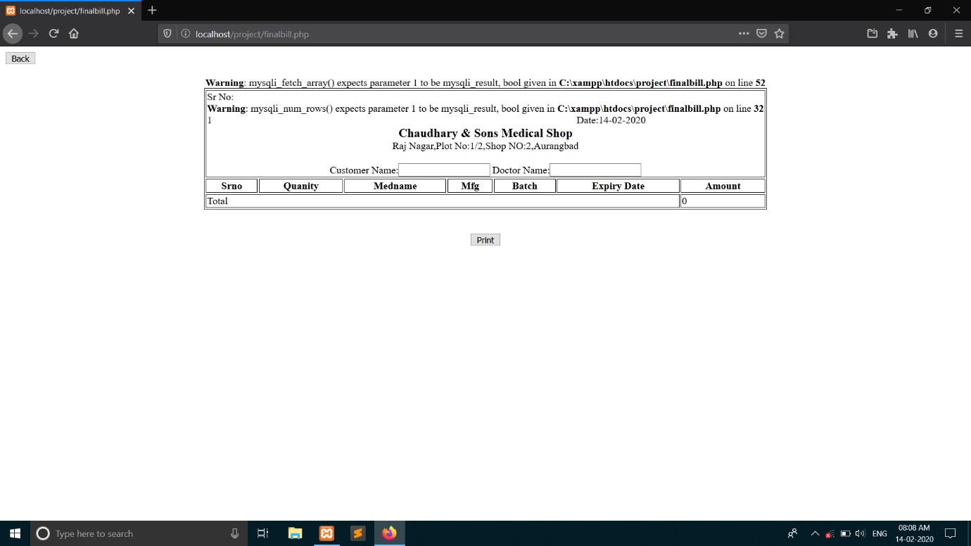

**11. Medicine Report**

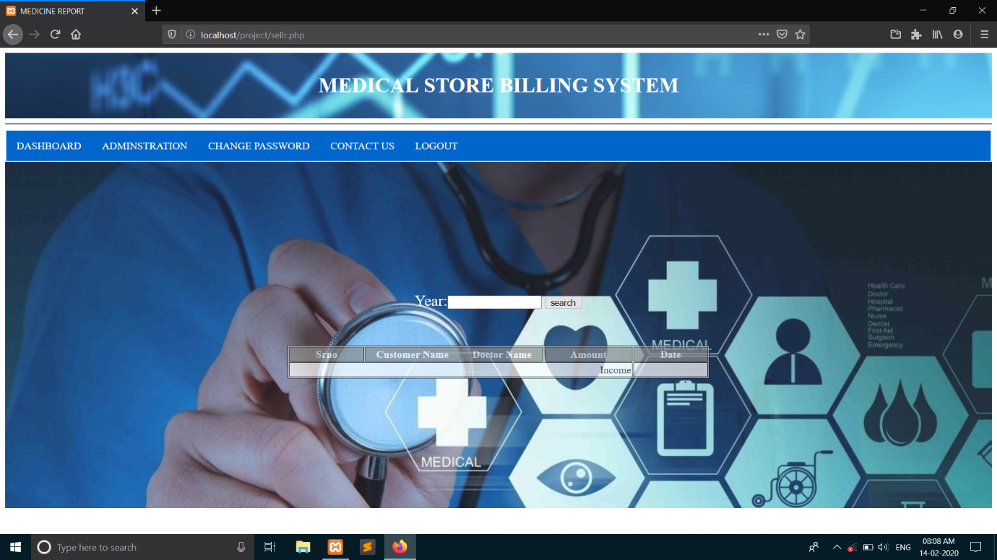

**12. Contact us.**

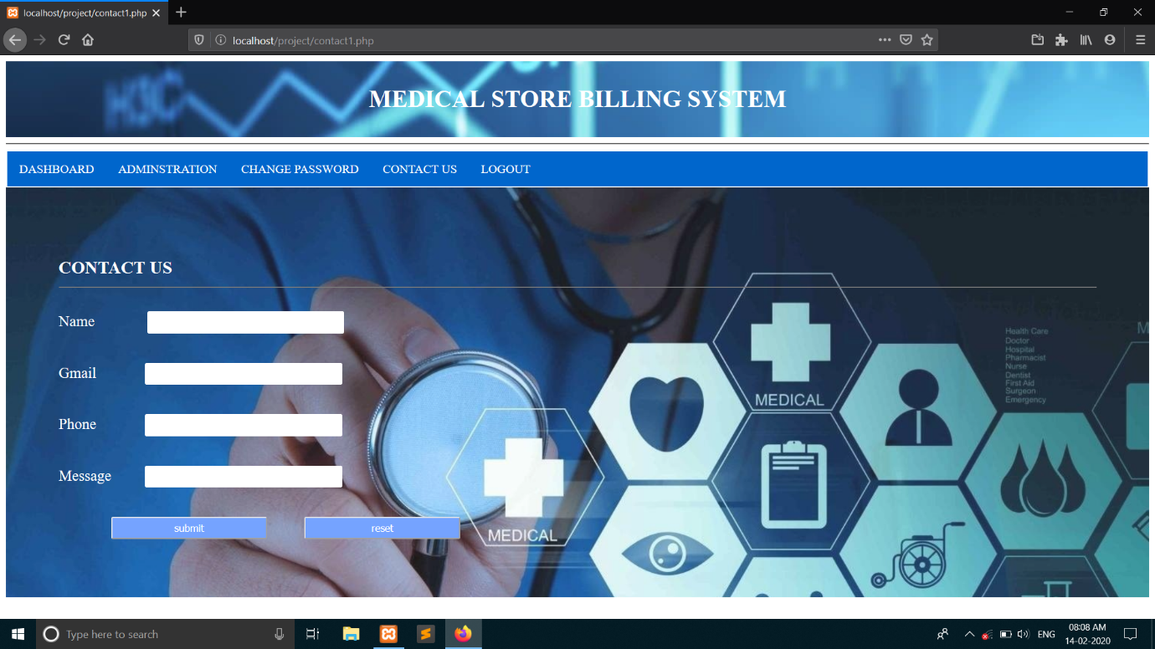

**13. Database Page**

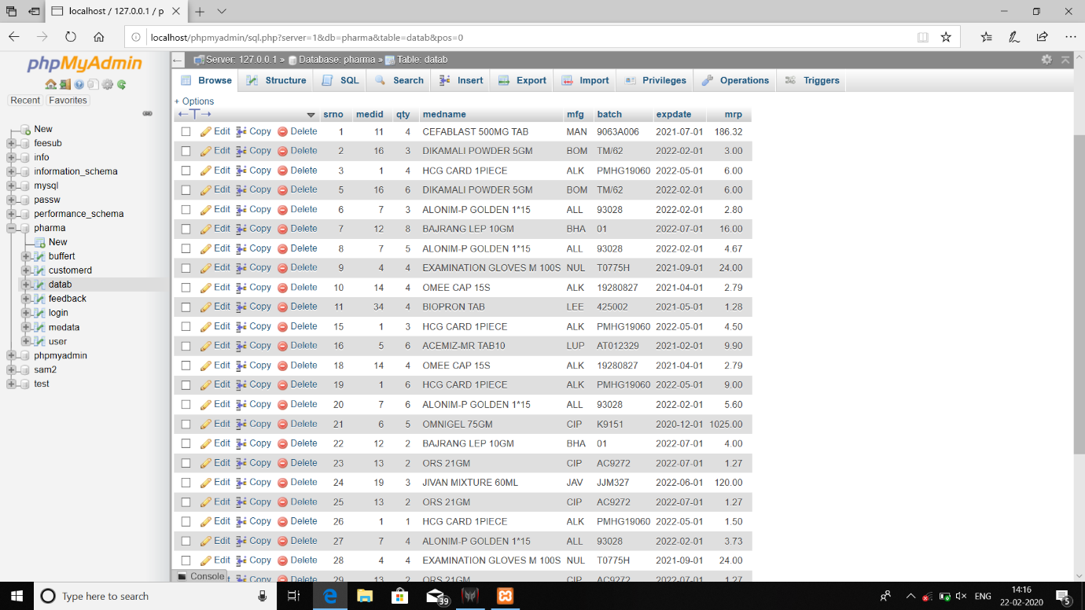

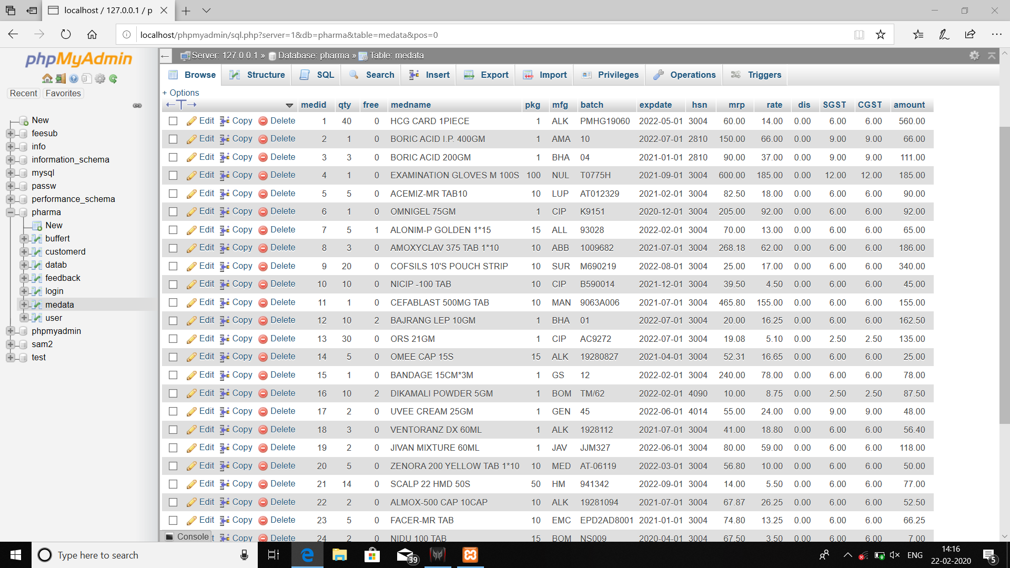

**14. Feedback Database**

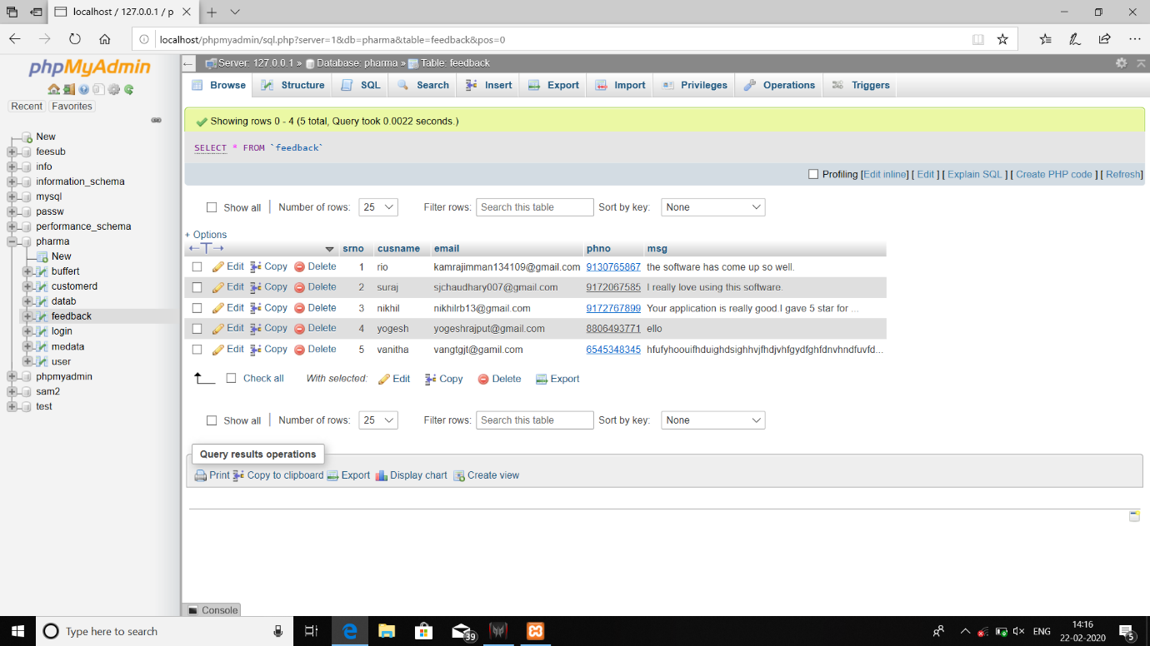

**15. Login Database**

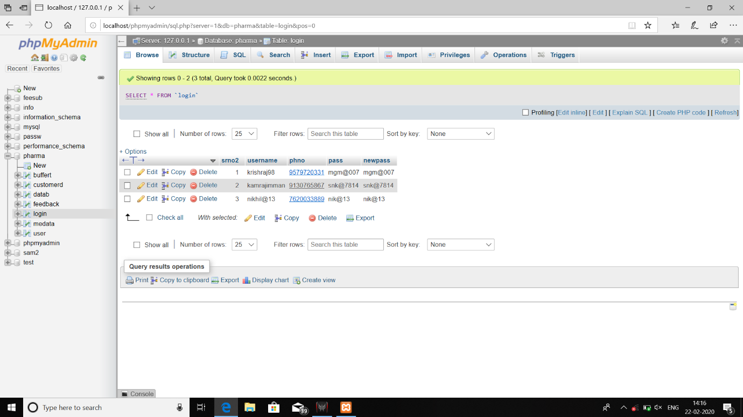

**CONCLUSION**

We still have much more to accomplish in this project. Yet at the current stage it is usable to a certain limitations. We are happy with the outcome and same will be the response of the customers who will use our project. The project has been made as simple as possible to be user-friendly. User can always keep an eye on the available stocks.

We plan to provide more facilities in upcoming time and do changes as requested by the customers.